भारतमौसमविज्ञानविभाग |  | India Meteorological Department
Wednesday, 25th June 2025 (4th Ashadha 1947 Saka)
Summary of observations recorded at 0830 hours IST: Southwest monsoon has further advanced over remaining parts of north Arabian Sea; some more parts of Rajasthan, West Uttar Pradesh, Haryana and Punjab. The Northern Limit of Monsoon passes through 26.0°N/60.0°E, 26.0°N/65.0°E, 26.5°N/70.0°E, Nagaur, Sikar, Bharatpur, Rampur, Sonipat, Bhatinda and 31.0°N/70.0°E. Conditions are favourable for further advance of Southwest monsoon over some more parts of Rajasthan, Punjab, Haryana; Delhi and remaining parts of West Uttar Pradesh during next 24 hours. The upper air cyclonic circulation over central parts of south Uttar Pradesh lay over central parts of northeast Madhya Pradesh of today morning. It then persisted over the same region extended upto 5.8 km above m. s. l. tilting southwards with height. The upper air cyclonic circulation over northwest Bay of Bengal and adjoining north Odisha-west Bengal coasts persisted and extended upto 7.6 km above m. s. l. tilting southwestwards with height. Under its influence, a low-pressure area is likely to form over the same region during next 24 hours. The trough from northeast Arabian Sea to the cyclonic circulation over south Jharkhand & neighbourhood ran from northeast Arabian Sea to the cyclonic circulation over northwest Bay of Bengal and adjoining north Odisha-west Bengal coasts of today morning. It then ran from northeast Arabian Sea to the cyclonic circulation over northeast Madhya Pradesh across south Gujarat, north Madhya Maharashtra and extended between 3.1 & 5.8 km above m. s. l. The upper air cyclonic circulation over central Assam & neighbourhood became less marked. The trough ran from Punjab to north Bangladesh across the cyclonic circulation over central parts of south Uttar Pradesh became less marked. The upper air cyclonic circulation over south Jharkhand & neighbourhood became less marked. The trough ran from central parts of Pakistan to the cyclonic circulation over northwest Bay of Bengal adjoining north Odisha-West Bengal coasts across northern parts of Rajasthan, cyclonic circulation over central parts of northeast Madhya Pradesh, north Chhattisgarh and north Odisha extending upto 1.5 km above m. s. l.of today morning. It then became less marked.
Day temperatures were markedly above normal (> 5.1°C) at few places over Jammu-Kashmir-Ladakh-Gilgit-Baltistan-Muzaffarabad; at isolated places over Odisha. appreciably above normal (3.1°C to 5.0°C) at isolated places over Nagaland, Manipur, Mizoram & Tripura, Himachal Pradesh and Tamil Nadu, Puducherry & Karaikal. above normal (1.6°C to 3.0°C) at few places over Lakshadweep; at isolated places over Assam & Meghalaya, Gangetic West Bengal, west Rajasthan and Kerala & Mahe. near normal (-1.5°C to 1.5°C) at many places over Andaman & Nicobar Islands, Jharkhand, Konkan & Goa, Marathwada and south interior Karnataka; at most places over sub Himalayan West Bengal & Sikkim and coastal Karnataka; at few places over Bihar, east Uttar Pradesh, Uttarakhand, Saurashtra & Kutch, Madhya Maharashtra, Telangana, Rayalaseema and north interior Karnataka; at isolated places over west Uttar Pradesh, Chhattisgarh and Coastal Andhra Pradesh & Yanam. Yesterday, the highest maximum temperature of 42.8°C was reported at Sriganganagar (Rajasthan).
Preliminary Earthquake Report: An earthquake shock of Slight intensity at its origin with epicenter at Lat. 09.48° North and Long. 94.17° East, 276 km N of Campbell, Andaman & Nicobar island; India; about 2408 kms away from Pune, was recorded by the seismographs in the CR & S Office, Pune at 07 Hrs. 06 Min. 01 Secs. IST on 25-06-2025 having its magnitude 4.8 on the Richter scale.
The Southwest Monsoon has been active over Jharkhand, east Madhya Pradesh and north interior Karnataka. It has been subdued over east Uttar Pradesh, Marathwada and Rayalaseema.
Total 309 station reported rainfall today. Total rainfall is 290.2 cm. Total 296 Station reported rainfall today whose normals are available. Total rainfall is 268.7 cm with normal station total is 246.7 cm.
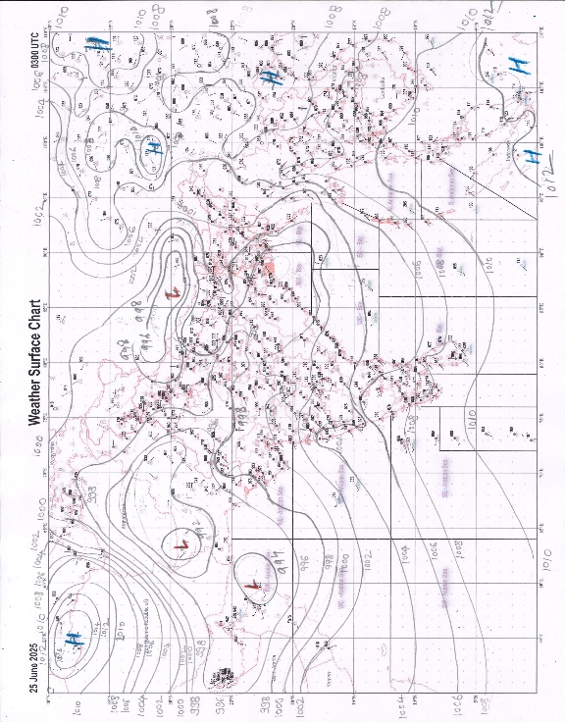 | 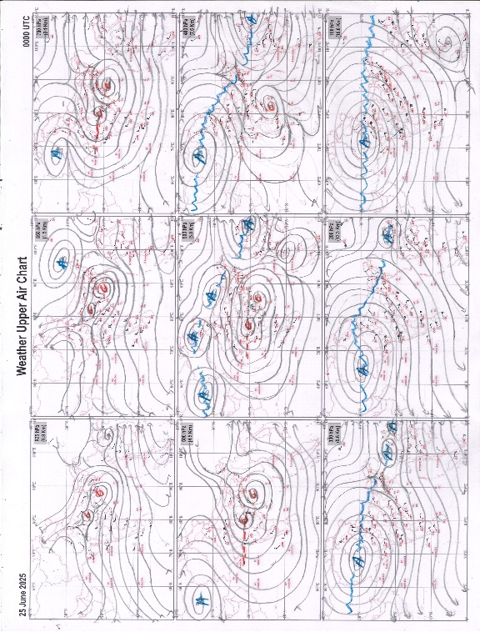
g.1. Analysed surface chart based on 03z observation | Fig.2. Analysed upper air chart based on 00z observation

Dr. S D Sanap.
Scientist ‘D’
CR & S Office, Pune  Issued at 1245 hrs. IST |  | Weather Forecasting Division  CR&S, Pune

Indian regions | Realised rainfall (chief amount in cm during past 24 hrs):
East | most places: Arunachal Pradesh+ and Nagaland-Manipur-Mizoram-Tripura+  many places: Assam & Meghalaya+, Sub-Himalayan West Bengal & Sikkim+ and Jharkhand+  a few places: Gangetic West Bengal and Odisha+  isolated places: Bihar+  Rajnagar 11.2, Imamganj 10.8, Chauldhowaghat 9.9, Kampur 9.2, Chandua kuliana 8.4, Basar AWS 8.3, Basar 8.2, Silchar 7.9, Chausha 7.8, Pasighat AP 7.7, Gola 7.5, Washabari tea estate 7.4, Jamtara fmo 7.1, Chottabekra 7.0, Kalimpong 6.4, Oodlabari tea estate 6.3, Ukhrul & Ranchi AP 5.6 each, Phulberia 5.0, Kailashahar AP 4.6, Chandbali 4.5, Tantloi 3.7, Jamui 2.1, Diamond harbour 1.5.
North | many places: Uttarakhand++ and east Rajasthan+++  a few places: Himachal Pradesh+++  isolated places: Uttar Pradesh+, Haryana+++, Punjab, Jammu-Kashmir and Ladakh+ and west Rajasthan+  Sallopat SR 19.0, Shahbad 17.0, Palampur 14.5, Sagwara 13.7, Haldwani 12.9, Nakur 11.4, Jogindarnagar 11.3, Desuri 11.2, Katra 10.9, Babain REV 10.8, Nahan 9.4, Reasi ARG 9.3, Reasi kvk AWS 9.1, Jaipur AP 7.8, Loharkhet 6.6, Patti 6.5, Phangota 5.7, Budhana 5.5, Robertsganj 4.7, Karnal & Didwana 4.1 each, Nainital 3.4, Budh singh kvk AWS 2.2, Ayodhya (ag) 1.7, Muzaffarnagar 1.3, Nagaur tehsil SR 0.7, Amritsar 0.5.
Central | most places: east Madhya Pradesh+++  many places: west Madhya Pradesh#, Vidarbha+ and Chhattisgarh+  Kathiwada 21.1, Mandla 13.1, Vijayraghogarh 11.8, Singodi 11.6, Jhabua-aws 8.9, Bamhnidih 8.2, Korchi 7.7, Janjgir 7.4, Mulchera 6.9, Rajgarh 6.0, Bramhapuri 2.6, Kanker 1.0.
Peninsula | most places: Gujarat Region#, Konkan & Goa+, coastal Karnataka++ and Kerala+  many places: Madhya Maharashtra+++, coastal Andhra Pradesh and north interior Karnataka++  a few places: Telangana+ and south interior Karnataka+  isolated places: Saurashtra & Kutch, Marathwada, Rayalaseema and Tamil Nadu+  Lunawada 21.7, Nandod 21.0, Dahod 19.2, Khanapur 17.1, Radhanagari 15.8, Ajra 15.6, Castle rock & Yellapur 13.1 each, Londa 12.9, Hunchadakatte 10.8, Kammardi 10.7, Agumbe emo & Vyttiri 9.5 each, Sengulam dam AWS 9.1, Chinnakalar 8.6, Valparai PTO 8.0, Cincona 7.5, Mulug 7.1, Govindaraopet 6.8, Dodamarg 6.6, Karipur ap. 6.5, Sangameshwar devrukh 5.8, Mahabaleshwar 5.6, Mangaluru AP 4.6, Belagavi AP 4.5, Matheran 4.1, Anakapalle 2.6, Yelamanchili & Hanamkonda 2.2 each, Nandigama 1.6, Alur 1.1, Ardhapur & Nandikotkur 0.7 each, Kannad 0.6, Keshod 0.5, Barvala & Vallabhipur 0.3 each, Kurnool 0.1.
Islands | a few places: Andaman & Nicobar++  isolated places: Lakshadweep◆  Long island 16.1, Maya bandar 4.8, Port blair 0.7, Minicoy 0.1.
Table 2. Forecast / warnings (distribution of rain / thundershowers) for 7 days (valid from time of origin upto 0830 hrs IST of next day)
Sr N. |  | Sub-division Name | Day 1 | Day 2 | Day 3 | Day 4 | Day 5 | Day 6 | Day 7 | Sr. No. | Sub-division Name | Day 1 | Day 2 | Day 3 | Day 4 | Day 5 | Day 6 | Day 7
 |  |  | 25 Jun | 26 Jun | 27 Jun | 28 Jun | 29 Jun | 30 Jun | 01 July |  |  | 25 Jun | 26 Jun | 27 Jun | 28 Jun | 29 Jun | 30 Jun | 01 July
 | 1 | Andaman Nicobar Islands | F  | W  | W  | W  | F  | F  | F  | 19 | west Madhya Pradesh | W ++  | W ++  | W +  | W +  | W +  | F + | F + 
 | 2 | Arunachal Pradesh | F +  | F +  | F +  | W ++ | W + | W + | F + | 20 | east Madhya Pradesh | W ++  | W ++ | W + | W +  | W +  | W + | W + 
 | 3 | Assam-Meghalaya | W +  | F +  | F +  | F + | F + | F + | F + | 21 | Gujarat region | W #  | W ++  | W ++  | W ++  | W ++  | W ++ | W ++ 
 | 4 | Nagaland-Manipur-Mizoram-Tripura | W +  | F +  | F +  | F  | F +  | F + | F +  | 22 | Saurashtra and Kutch | W +  | W + | W + | W + | W + | W + | W +
 | 5 | Sub Himalayan West Bengal/Sikkim | F | F | W +  | W ++ | W + | W + | F + | 23 | Konkan and Goa | W +  | W +  | W++ | W++ | W++ | W++ | W ++ 
 | 6 | Gangetic West Bengal | W+ | W+ | W + | W | F | F | F | 24 | Madhya Maharashtra | F++ | S ++ | S ++ | S ++ | F ++ | F++ | F ++
 | 7 | Odisha | W# | W++ | F +  | F + | S | S | S | 25 | Marathwada | I | I | I | I | I | I | I
 | 8 | Jharkhand | W+ | W++ | W+ | W+ | W+ | F | F+ | 26 | Vidarbha | W +  | W +  | F+ | F  | F  | S + | W 
 | 9 | Bihar | S  | S  | S + | F++ | F++ | F+ | F++ | 27 | Chhattisgarh | W +  | W +  | W + | W +  | W +  | F + | F + 
 | 10 | east Uttar Pradesh | I  | S  | F  | F +  | W +  | W++ | W +  | 28 | Coastal Andhra Pradesh and Yanam | W +  | F  | S  | S  | S  | S | S 
 | 11 | west Uttar Pradesh | S ++  | F +  | F +  | F +  | F +  | F +  | F +  | 29 | Telangana | S +  | S  | I  | I  | I  | I | I 
 | 12 | Uttarakhand | W++ | W++ | W++ | F+ | F+ | F+ | F+ | 30 | Rayalaseema | S | I | I | I | I | I | I
 | 13 | Haryana,Chandigarh and Delhi | W ++  | F +  | F +  | W +  | W +  | W +  | F +  | 31 | Tamil Nadu, Puducherry and Karaikal | I ++  | S++ | S+ | S+ | I | I | I
 | 14 | Punjab | W ++  | W ++  | F +  | F  | W +  | W +  | F +  | 32 | Coastal Karnataka | W ++  | W ++ | W + | W + | W | W | W
 | 15 | Himachal Pradesh | W ++  | W +  | W + | F + | F + | F + | F + | 33 | North interior Karnataka | F ++  | F +  | S + | S | S | I | I
 | 16 | Jammu-Kashmir and Ladakh | W++ | W+ | W+ | S  | S  | S  | S  | 34 | South interior Karnataka | F ++  | F +  | S + | S + | S | I | I
 | 17 | west Rajasthan | S  | S + | F++ | F+ | F + | S  | I + | 35 | Kerala and Mahe | W ++  | W ++  | W + | W + | F | F | S
 | 18 | east Rajasthan | F++ | F ++ | F++ | F++  | F+ | S  | S+ | 36 | Lakshadweep | W | W  | W | W | F | F | S
Legends: D = Dry I = Isolated S = Scattered F = Fairly widespread W = Widespread #= heavy to very heavy rain at a few places with extremely heavy rain at isolated places +++= heavy rain at a few places with very heavy rain at Isolated places ++= heavy to very heavy rainfall @=Isolated exceptionally heavy rainfall + = heavy rain ●/*= rain or snow ♦ = very light rain ≡=fog= thunderstorm with lightning =Squall / Gusty / gale / strong wind ­ =cold wave/cold day += heat wave/warm night/hot and humid weathe r=Duststorm =ground frost = Hail
Fig. 4: Districtwise warnings for five days for Maharashtra State
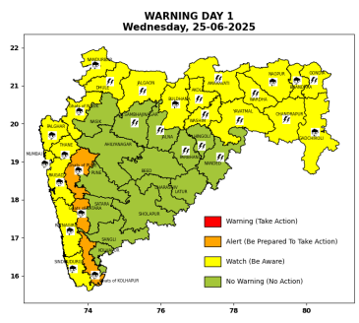 | 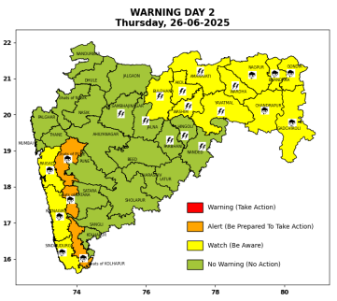 | 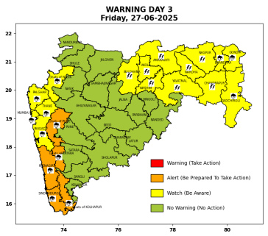 | 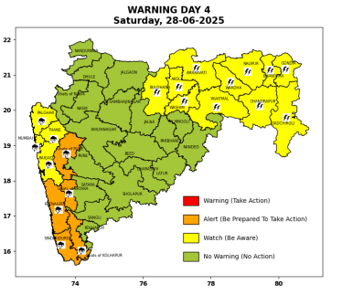 | 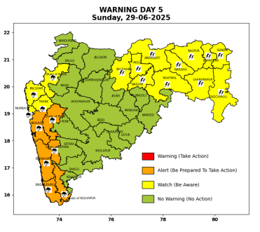

Pune, Lohegaon and Pashan observations at 0830 hrs. IST of Today
 | Temperature (°C) |  |  |  |  | Humidity (%) |  |  |  | Rainfall (mm)
 | Max.  past  24 hrs | Dep.  from  normal | Min.  past  24 hrs. | Dep.  from  normal | Dry  Bulb | At 0830 hrs. IST | Dep.  From  normal | At 1730  hrs. IST of y’day | Dep.  from  normal | Past  24 hrs. | Since  1st June | Dep.  from  normal
PNE | 29.7 | -0.7 | 23.9 | 1.1 | 25.4 | 81 | 0.0 | 72 | 2.0 | 0.9 | 260.7 | 137.4
PSN | 28.6 | - | 22.7 | - | 24.6 | 89 | - | 79 | - | 1.4 | 293.3 | -
LHG | 31.5 | 0.5 | 25.2 | 4.2 | 26.4 | 80 | 0.0 | 66 | 1.0 | 0.0+ | 241.8 | 162.6

 |  |  |  |  |  |  | Local (Pune and neighbourhood) forecast
Max./Min. Temperature (°C) |  |  |  |  |  |  |  |  | Weather
Date | Pune | Pashan | Lohegaon | Chinchwad | Lavale | Magarpatta | NDA | Koregoan Park
25/06/25 | 29 / 23.9* | 28 / 22.7* | 31 / 25.2* | 29 / 23.5* | 27 / 22.7* | 29 / 25.7* | 28 / 24.9* | 29 / 25.4* | Generally cloudy sky. Light rain very likely. (Heavy to very heavy rainfall at isolated places in ghat areas)
26/06/25 | 30 / 23 | 29 / 22 | 31 / 25 | 29 / 23 | 29 / 22 | 30 / 25 | 28 / 24 | 30 / 25 | Generally cloudy sky. Light rain very likely. (Heavy to very heavy rainfall at isolated places in ghat areas)
27/06/25 | 29 / 23 | 28 / 22 | 31 / 25 | 29 / 23 | 28 / 22 | 29 / 25 | 28 / 24 | 29 / 25 | Generally cloudy sky. Light rain very likely. (Heavy to very heavy rainfall at isolated places in ghat areas)
28/06/25 | 29 / 22 | 28 / 21 | 31 / 24 | 29 / 22 | 28 / 21 | 29 / 24 | 28 / 23 | 29 / 24 | Generally cloudy sky. Light to moderate rain very likely. (Heavy to very heavy rainfall at isolated places in ghat areas)
29/06/25 | 28 / 22 | 27 / 21 | 30 / 24 | 28 / 22 | 27 / 21 | 28 / 24 | 27 / 23 | 28 / 24 | Generally cloudy sky. Light to moderate rain very likely. (Heavy rainfall at isolated places in ghat areas)
30/06/25 | 28 / 21 | 27 / 20 | 30 / 23 | 28 / 21 | 27 / 20 | 28 / 23 | 27 / 22 | 28 / 23 | Generally cloudy sky. Light to moderate rain likely. (Heavy rainfall at isolated places in ghat areas)
01/07/25 | 28 / 21 | 27 / 20 | 30 / 23 | 28 / 21 | 27 / 20 | 28 / 23 | 27 / 21 | 28 / 23 | Generally cloudy sky. Light to moderate rain likely. (Heavy rainfall at isolated places in ghat areas)
Rainfall Distribution |  |  | Rainfall Categories | Rainfall (mm) |  | Cloud condition |  |  |  | Rainfall Intensity |  | Range
Widespread (W) | 76-100% |  | Very Light rain | Trace to 2.4 mm |  | Mainly clear sky |  | 1-2 oktas |  | Light Spell |  | 1 cm/hr
 |  |  | Light rain | 2.5 to 15.5 mm |  | Partly cloudy sky |  | 3-4 oktas |  | Moderate Spell |  | 1-2 cm/hr
Fairly Widespread (FW) | 51 – 75% |  | Moderate rain | 15.6 to 64.4 mm |  | Generally cloudy sky |  | 5-7 oktas |  | Intense Spell |  | 2-3 cm/hr
Scattered (S) | 26 – 50% |  | Heavy rain | 64.5 to 115.5 mm |  | Overcast |  | 8 oktas |  | Very Intense Spell |  | 3-5 cm/hr
isolated (I) | 1 – 25% |  | Very heavy rain | 115.6 to 204.4 mm |  |  |  |  |  | Extremely Intense Spell |  | 5-10 cm/hr
D (D) | No Rain |  | Extremely heavy rain | ≥ 204.5 mm |  |  |  |  |  | Cloudburst |  | > 10 cm/hr
Probability Terms in %: |  |  | Heavy snow | 6.5 to 11.5 cms water equivalent of rain
unlikely | < 25 |  | Very heavy snow | 11.6 to 20.4 cms water equivalent of rain
likely | between 25 50
very likely | between 51 75
most likely | >75
* = realized temperature
Mumbai (Colaba) |  |  |  | Nagpur (AP)
Date 2025 | T max °C | T min °C | Weather | T max °C | T min °C | Weather
25/06 | 31 | 25 | Generally cloudy sky with heavy rainfall. | 33 | 24 | Generally cloudy sky with heavy rainfall or thundershowers accompanied with Lightning.
26/06 | 30 | 23 | Generally cloudy sky with moderate rain. | 30 | 24 | Generally cloudy sky with heavy rainfall or thundershowers accompanied with Lightning.
27/06 | 29 | 23 | Generally cloudy sky with heavy rainfall. | 32 | 24 | Generally cloudy sky with a few spells of rain or thundershowers or thundershowers accompanied with Lightning.
28/06 | 30 | 25 | Generally cloudy sky with heavy rainfall. | 30 | 25 | Generally cloudy sky with a few spells of rain or thundershowers or thundershowers accompanied with Lightning.
29/06 | 31 | 25 | Generally cloudy sky with heavy rainfall | 29 | 24 | Generally cloudy sky with a few spells of rain or thundershowers or thundershowers accompanied with Lightning.
30/06 | 31 | 25 | Rain. | 29 | 24 | Generally cloudy sky with possibility of rain or thunderstorm
01/07 | 31 | 25 | Rain. | 30 | 25 | Generally cloudy sky with possibility of rain or thunderstorm

